Table of Content
1.0 Introduction 2
2.0 Home Page 3
2.1 Output 3
2.2 Explanation 3
3.0 Add Contact 7
3.1 Output 7
3.2 Illustration 8
3.3 Explanation 9
4.0 Display All Contacts 11
4.1 Output 11
4.2 Illustration 12
4.3 Explanation 12
5.0 Update Contact Information 13
5.1 Output 13
5.2 Illustration 14
5.3 Explanation 15
6.0 BubbleSort 17
6.1 How does bubble sort work on contact management systems? 17
6.2 Code explanation 20
7.0 Search Contacts 22
7.1 Output 22
7.2 Illustration 23
7.3 Explanation 24
8.0 Delete Contact 25
8.1 Output 25
8.2 Illustration 27
8.3 Explanation 28
9.0 Conclusion 29
10.0 Reference 30

1.0 Introduction
Data structures are a specific way of organizing data in a specialized format on a computer so that the information can be organized, processed, stored, and retrieved quickly and effectively. They are a means of handling information, rendering the data for easy use.Every application, piece of software, or programs foundation consists of two components like algorithms and data. Data is information, and algorithms are rules and instructions that turn the data into something useful to programming.
A linked list is a linear data structure which can store a collection of "nodes" connected together via links i.e. pointers. Linked lists nodes are not stored at a contiguous location, rather they are linked using pointers to the different memory locations. A node consists of the data value and a pointer to the address of the next node within the linked list.
Also, a linked list is a dynamic linear data structure whose memory size can be allocated or de-allocated at run time based on the operation insertion or deletion, this helps in using system memory efficiently. Linked lists can be used to implement various data structures like a stack, queue and graph.
We will use the Bubble Sort to complete this project because this is the simplest of the sorting techniques.In the bubble sort technique, each of the elements in the list is compared to its adjacent element. Thus if there are n elements in list A, then A[0] is compared to A[1], A[1] is compared to A[2] and so on.After comparing if the first element is greater than the second, the two elements are swapped then.Using the bubble sort technique, sorting is done in passes or iteration. Thus at the end of each iteration, the heaviest element is placed at its proper place in the list. In other words, the largest element in the list bubbles up.

2.0 Home Page

2.1 Output
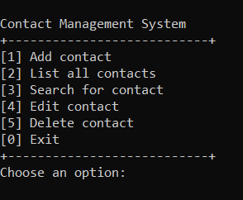
Image of Contact Management System

This is our home page and is a program written in C++. The program implements a contact management system based on a linked list data structure. We have 6 options you can choose. For example, if you type ‘1’ then will go to Add contact.

2.2 Explanation
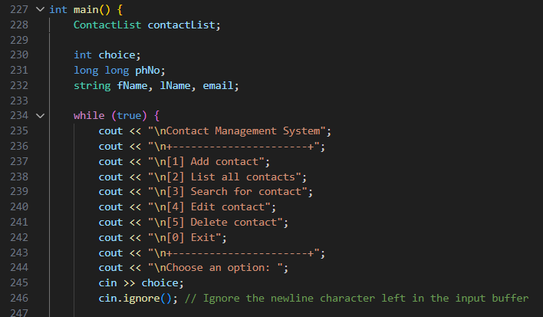
Image of code multiple option
Lines | Explanation
228 | Create a ContactList object contactList to manage the contact information after the user enters.
234-303 | Use the while (true) loop to continuously display the main menu until the user chooses to exit.
235-244 | Use cout << to output the option list including adding contacts, listing all contacts, searching contacts, editing contacts, deleting contacts and exiting.
245-246 | Use cin >> choice to read the options entered by the user.
Table of explanation about code Home Page
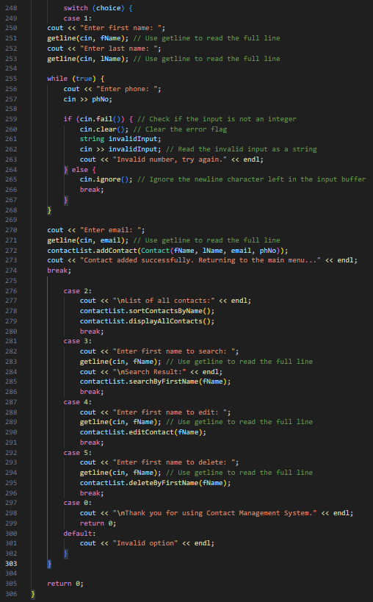
Image of code switch function

Lines | Explanation
249-274 | Add contact: Read the contact information entered by the user, such as name, phone number and email address, and call the addContact function to add the contact.
276-280 | List all contacts: Call the sortContactsByName function to sort the contacts by name, and call the displayAllContacts function to display all contacts.
281-286 | Search for contacts: Read the name entered by the user, and call the searchByFirstName function to search for contacts.
287-291 | Edit contact: Read the name entered by the user, and call the editContact function to edit the contact information.
292-296 | Delete contact: Read the name entered by the user, and call the deleteByFirstName function to delete the contact.
297-299 | Exit the program: Type ‘0’ to exit the loop and end the program.
300-301 | Otherwise : If the user types another letter will also end the program.

Table of explain code switch function

3.0 Add Contact

3.1 Output
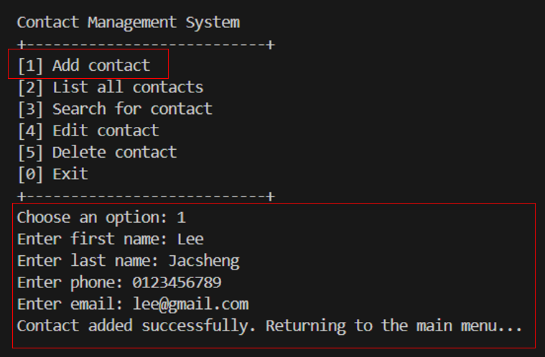
Image of Add contact function

This is our add contact function , the system will want the user to enter their first and last name , phone and email.After done everything will print out the information like “Contact added successfully. Returning to the main menu…..”.

3.2 Illustration
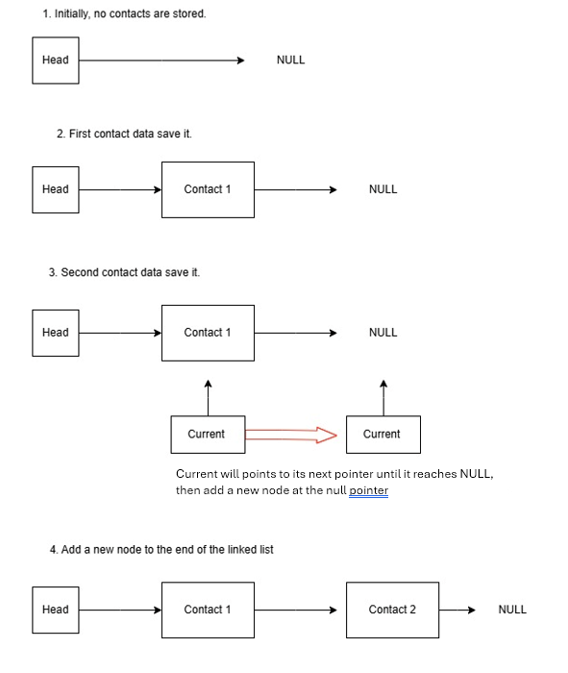
diagram of Add contact

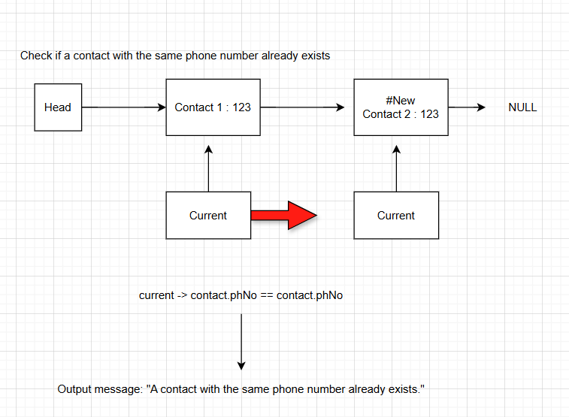
diagram of Add contact function

3.3 Explanation
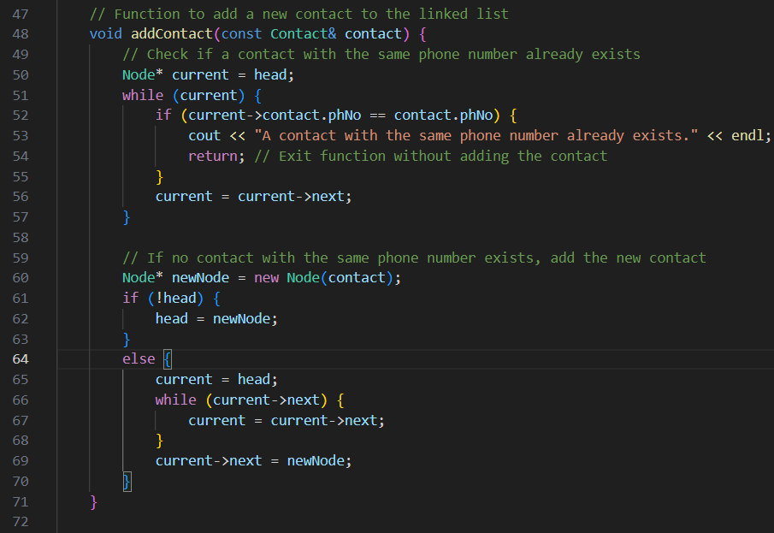
Image of code add content function
Lines | Explanation
50 | Initialize a pointer current to point to the head of the linked list.
51-57 | Traverse the linked list until current becomes nullptr also mean the end of the linked list.
52-55 | Checks whether the contact phone number of the current node is the same as the phone number of the contact to be added. Also, If the phone numbers are the same, output a prompt message.
56 | The current pointer will move to next node.
60 | A new node newNode is created, and contact is used as the data of the node.
61-63 | Check if the linked list is empty. If the linked list is empty, set the new node as the head node.
64-70 | Re-point the current pointer to the head of the linked list. Traverse the linked list until the last node is found. Add the new node newNode to the end of the linked list.

Table of explain Add contact function

4.0 Display All Contacts

4.1 Output
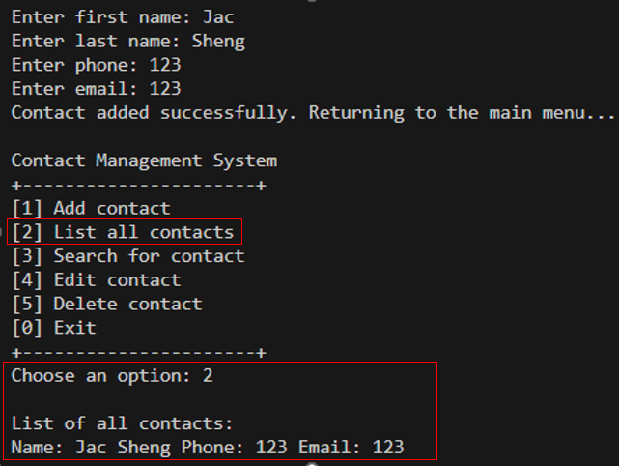
Image of List all contact function

After the user add contact , then they can check the list of all contacts and the system will display the information about the user contact.It should add contact first , otherwise the list will be empty.

4.2 Illustration
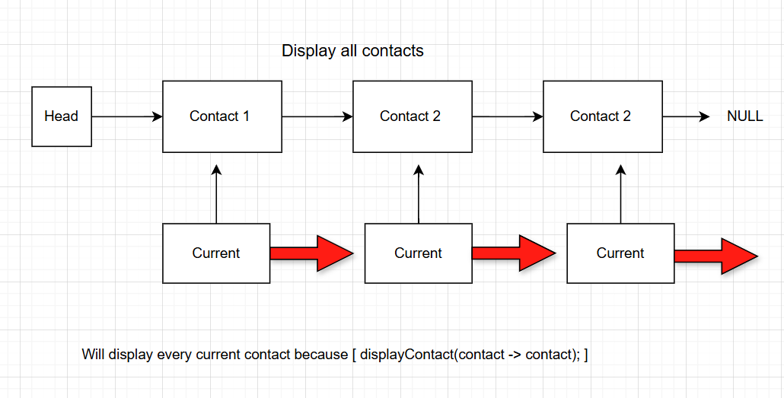
Contact 3
diagram of List all contact function

4.3 Explanation
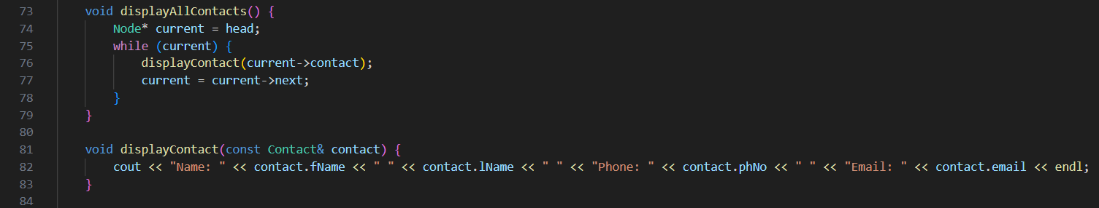
Image of code List all contact function

Lines | Explanation
76 | Call the displayContact function, passing the contact information of the current node as a parameter, and display the detailed information of the contact.
82 | Display contact details
Table of List all contact function

5.0 Update Contact Information

5.1 Output
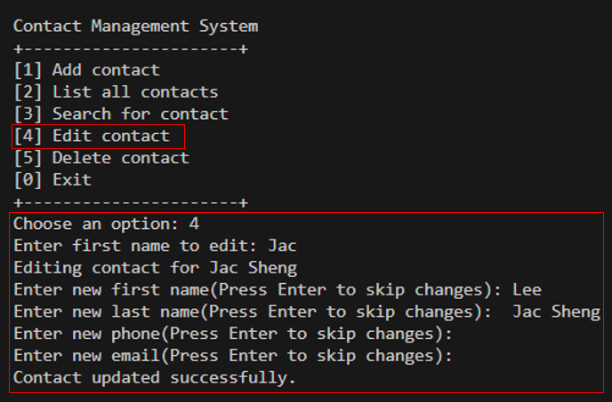
Image of Edit contact function

After users add content , they also can update or edit their contact again.System will use the first name of the user to find their information so if the system finds out then will display “Editing contact for user_name ” and users can edit their information now.

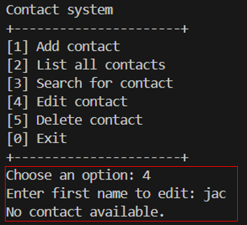
Image of Edit contact function when no user data

If not found then it will display “No contact available.”.

5.2 Illustration

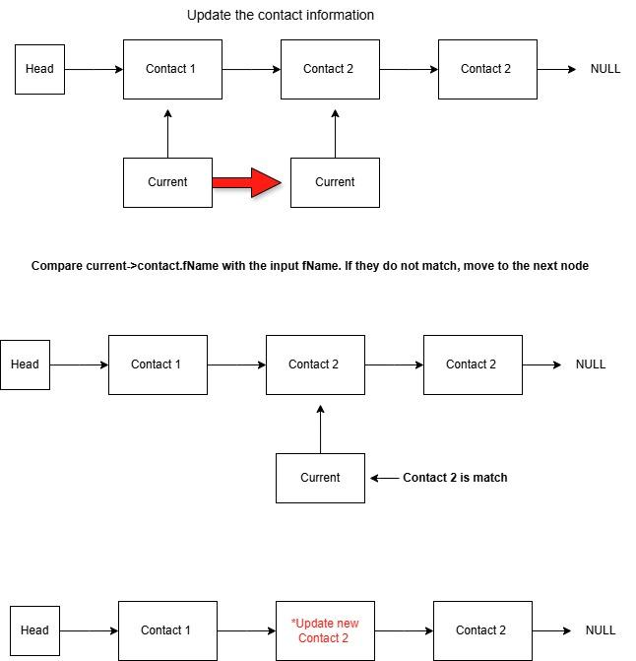
Contact 3
Contact 3
Contact 3
diagram of Update contact function

5.3 Explanation
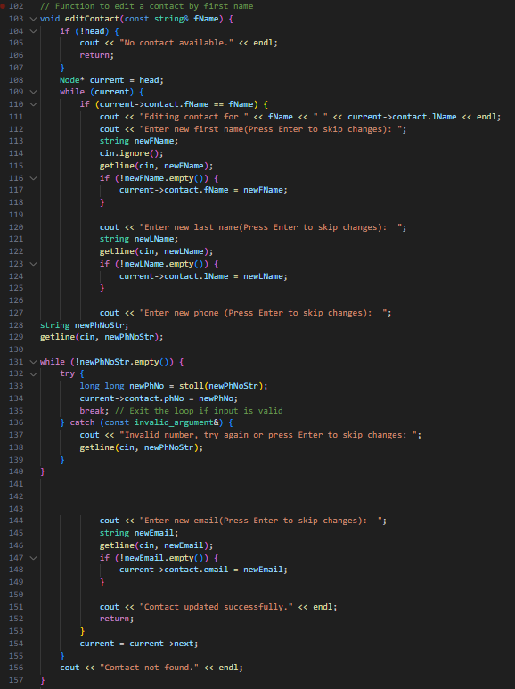
Image of code Edit contact function

Lines | Explanation
104 - 107 | Check if the linked list is empty, if so, it will output information.
110 | Check whether the contact name of the current node is the same as the name to be edited.
111 | Output prompt information, showing the name of the contact being edited.
112 -115 | -Prompt the user to enter a new name.  -The system will then declare a string variable newFName to store the new name. -Last will read the new name entered by the user.
116 -118 | If the new name is not empty, assign it to the current contact's name
132 - 135 | -Try to convert a string to a long integer  -Convert a string to a long integer  -Assign the new phone number to the current contact  -Exit the loop when the input is valid.
136 - 139 | -Catch invalid input exception  -Prompt the user that the input is invalid, re-enter or press Enter to skip  -Reread user input
154 - 156 | If no matching contact is found after traversing the linked list, a prompt message is output.
Table of explain Edit contact function

6.0 BubbleSort
For the contact management system, Bubble sort is used to sort the contact based on the first name. There are many reasons as to why bubble sort was implemented in the management system.

The first reason is that bubble sort is a simplest algorithm since its logic is straightforward and easy to understand creating a simple and easy to implement data structure. Bubble sort is considered useful since the contact management system does not use large datasets allowing for a simple and straightforward sorting method.

Furthermore, the bubble sort algorithm is stable and saves the value based on when the value is added. For example if there are two numbers inserted with the same value, the bubble sort will put the value that is inserted first in front creating a stable sorting method.

Lastly, using bubble sort it can be used to handle the contact. Since the contact information might increase or decrease, bubble sort can efficiently handle the changes without much issue. This allows bubble sort to be adaptive and run on O(n) since the values are already sorted and the changes do not affect much.

6.1 How does bubble sort work on contact management systems?
the first step to demonstrate how bubble sort works on the contact management system is to create a demonstration on what it would looked like
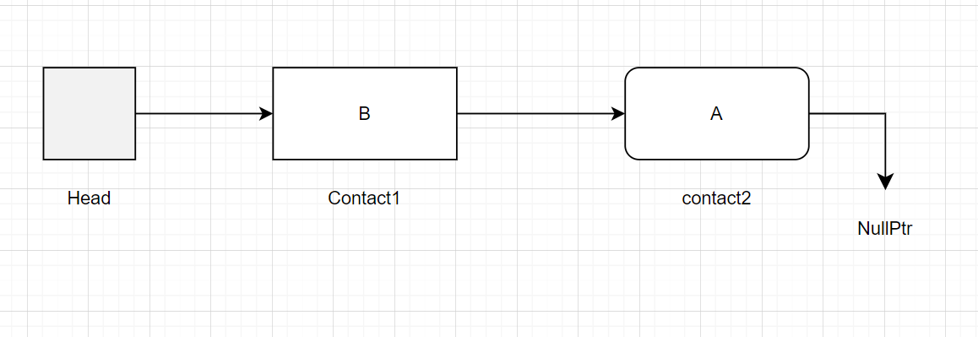
diagram of How bubble sort working

In this case, the string B and A are not sorted in the correct order. the bubble sort algorithm will create a node named current. and point it in the same direction as head
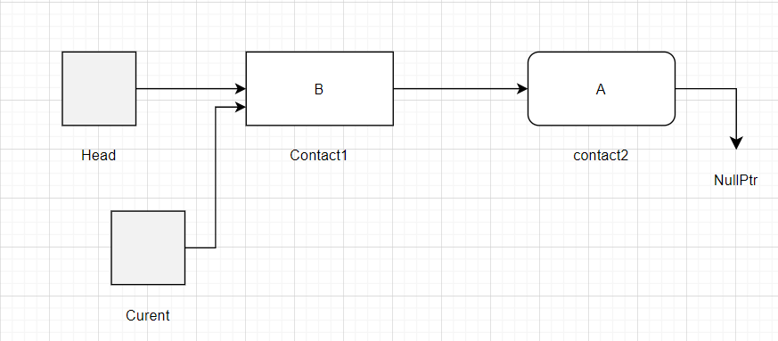
diagram of How bubble sort working

Typically, when current is initiated, the bubble sort is always pointing the same direction as head and in this case it's contact1. For the sake of simplicity, the node name is denoted as Contact1 and Contact2.

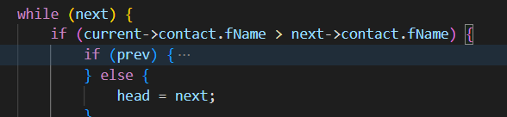
image of code how bubble sort working

In this line, it checks for if the value of current is bigger than the value of the next node. In this case, it is and the sorting will go with the if condition since the condition is true.
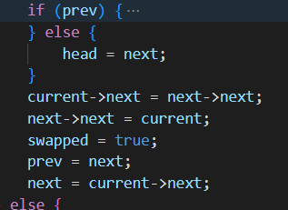
image of code how bubble sort working

Next, current will take on the value of contact1 which is currently B. Next, the Contact1 value in the diagram is replaced with the contact2 value. Since contact1 and contact2 both have the value of A due to the replacement. Current replace the value of contact1 with B creating a sorted array. 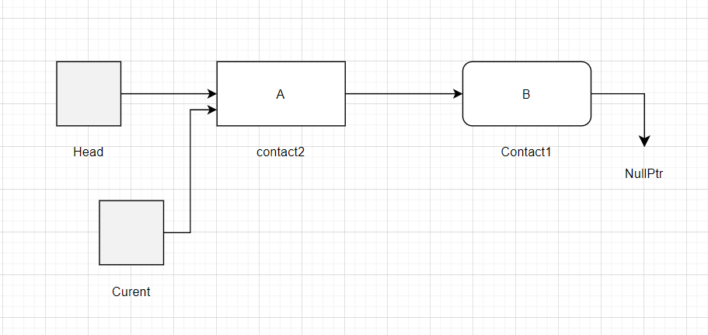
diagram of How bubble sort working

Since the comparison is false, the linked list goes to the else since in this new array contact2 is not larger than contact1.

Lastly, the swapped variable is a boolean variable. swapped is used in the case of more than 3 data. Since bubble sort focus on two data at once it can not do comparison and swap the value of the other strings, in order to make sure that all the values is sorted, the boolean swapped is used to as a way to sort every data since using it, it can went through the whole linked list and sort the data. once there is no longer any data needed to be sorted, the bubble sort change the bool value to false

6.2 Code explanation
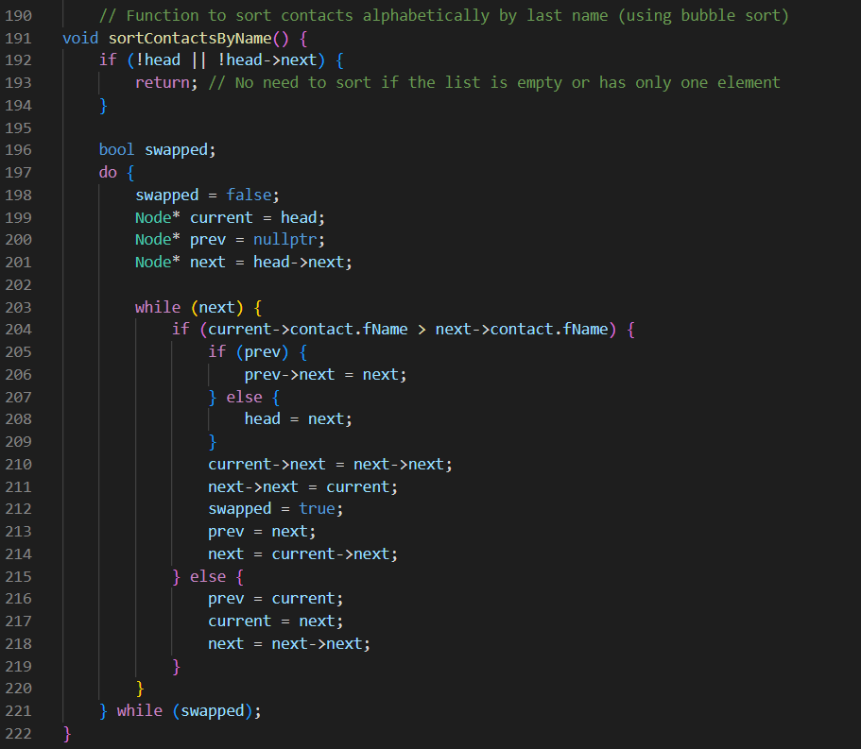
image of code how bubble sort working

line 192-194 | check if the linked list is empty or not
line 197 to line 200 | initialize the value current
line 203 | if there is data available on the next node, it will start the sorting process
line 204 | check if the node current is pointing is bigger than the next node
line 205-208 | move the linked list to the next value
line 210-214 | swap the values based on ascending order and change swapped to true for the sorting
line 216-218 | if the condition where the first value and second value is false, the sorting will only transverse through the linked list without doing any changes
line 221 | repeat the lopping until all the array is sorted and swapped become false
table of explain how bubble sort working

7.0 Search Contacts

7.1 Output
The menu list of number 3 will be chosen. The search function will start if the program have received the inputted number of “3”
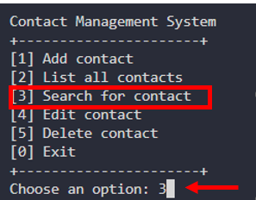
Image of CMS Menu
After choosing 3, The user will be ask to input a first name and is required for the program to continue
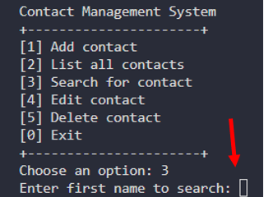
Image of selecting search

If the system does not find the First name, It will display “Contact not found” and the user will be redirected back to the selection menu.
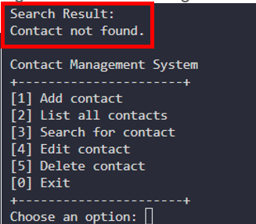
Image of fail search result
Upon successful finding the name, it displays the contact information after the first line. The user will be redirect back to the selection menu

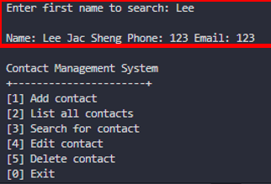
Image of Contacts Info

7.2 Illustration

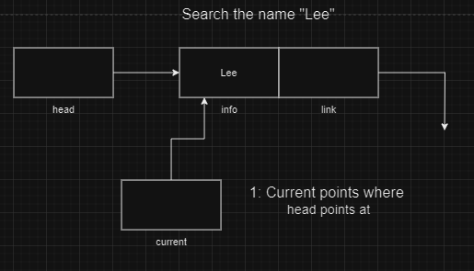
Image of diagram search example 1
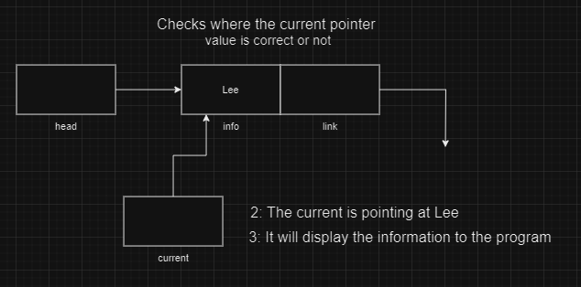
Image of diagram search example 2

7.3 Explanation

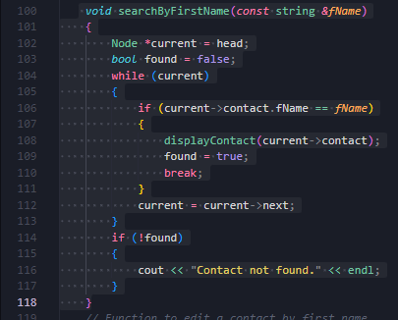
Image of a search function code

Lines | Explanation
100 | The function takes a string value from the user input.
102 | Sets the current pointer to point where head is pointing
103 | Create and set a boolean variable named “found” to false
106 - 111 | Check if the current pointer value is the same or not.  If it is the same value.  - The function called “displayContact” will be used
112 | Make the current pointer points to the next node if the condition is not met and there is still a node next to it.
114-116 | If the value was not found  - Display a message to the program
Table in 7.2 For line explanation

8.0 Delete Contact

8.1 Output

Number 5 will be chosen. The search function will start if the program has received the inputted number of “5”

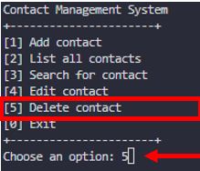
Image of Selecting delete contact

After choosing 5, the user will be asked to input a first name and is required for the program to continue
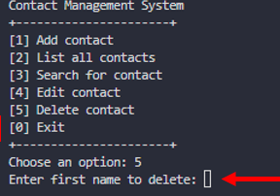
Image of inputting a name

If First name was not found, It will display “Contact not found” or “Contact list is empty” and the user will be redirected back to the selection menu.
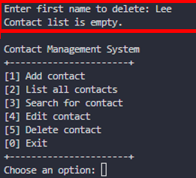
Image of failing a deletion

The name will be deleted when the user press enters, and user will be sent back to main menu
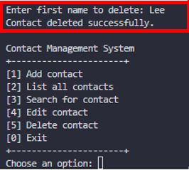
Image of deletion was successful

8.2 Illustration
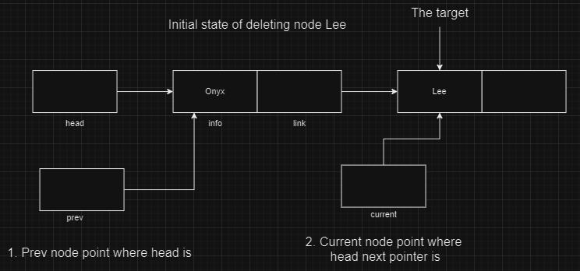
Image of diagram with deletion illustration 1

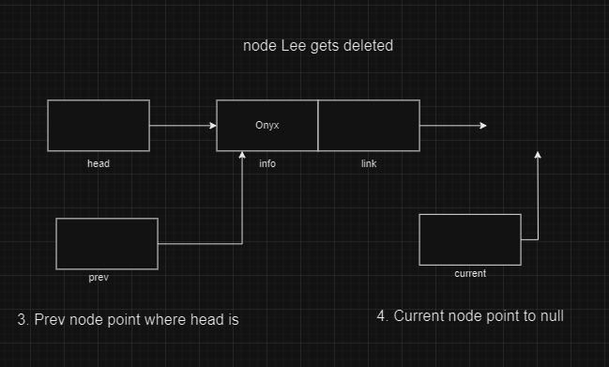
Image of diagram with deletion illustration 2

8.3 Explanation
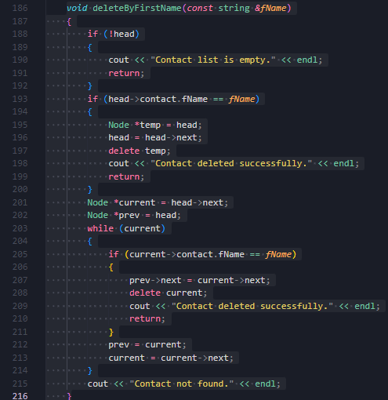
Image of code with deletion function
Line | Explanation
188 - 192 | Check the head is empty or not, the program continues if the head is not empty
193 - 200 | If the name is the head.  - Set the Temp to point where head is pointing  - Set the head to point where head next is pointing  - Delete the temp node and Output the message
201 - 202 | Making sure those node is pointing something
203 - 215 | Checks each node and the name was found or not.  If found:  - Set prev next pointer to point where current next pointer is  - Then delete the current node and display a message
212 - 213 | After the node deletion:  - Set prev pointer to point current  - Set current pointer to point its next pointer
215 | Display a message if all conditions were not met.
Table of 8.0 for explanation for each line of code

9.0 Conclusion

The main advantage of Bubble Sort is the simplicity of the algorithm. In bubble sort, with every pass, the largest element bubbles up to the end of the list if the array is sorted in ascending order. Similarly for the list to be sorted in descending order, the smallest element will be in its proper place at the end of every pass.
A linked list is a dynamic arrangement so it can grow and shrink at runtime by allocating and deallocating memory. So there is no need to give the initial size of the linked list.Beside, no memory wastage which is mean efficient memory utilization can be achieved since the size of the linked list increase or decrease at run time so there is no memory wastage and there is no need to pre-allocate the memory.
Apart from that, using the linked list will be more flexible because the elements in Linked List are not stored in contiguous memory locations unlike the array.Also efficient for large data when working with large datasets linked lists play a crucial role as they can grow and shrink dynamically.

10.0 Reference

- Biswal, avijeet (2021). What Is Data Structure: Types, Classifications and Applications. [online] Simplilearn.com. Available at: https://www.simplilearn.com/tutorials/data-structure-tutorial/what-is-data-structure.

- Tutorialspoint (n.d.). Data Structure and Algorithms - Linked List - Tutorialspoint. [online] www.tutorialspoint.com. Available at: https://www.tutorialspoint.com/data_structures_algorithms/linked_list_algorithms.htm.

- www.softwaretestinghelp.com. (n.d.). Bubble Sort In C++ With Examples. [online] Available at: https://www.softwaretestinghelp.com/bubble-sort/.

- GeeksforGeeks (2020). Advantages and Disadvantages of Linked List. [online] GeeksforGeeks. Available at: https://www.geeksforgeeks.org/advantages-and-disadvantages-of-linked-list/.

- GeeksforGeeks(2024). Bubble sort for linked list by swapping nodes. [online]. Available at: https://www.geeksforgeeks.org/bubble-sort-for-linked-list-by-swapping-nodes/

